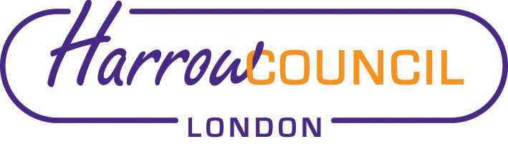
Harrow ASC and SACRE Meeting

Thursday 23 June 2022 at 7.30 p.m.
To be held via video conferencing

Enquiries & apologies to:
Vivian Wright, Clerk to SACRE
vmwright@waitrose.com

Adviser to SACRE: Lesley Prior

Agenda
- Welcome especially new Councillor representatives Janet Mote, Salim Chowdury, and Sasi Suresh (who is already known to us of course!) and their deputies, David Ashton, Hitesh Karia and Dr Antonio Weiss. Also two observers: Arvind Halai, who is active in the Swaminarayan temple on Kenton road and Yazad Bhadha from the Zoroastrian community.

- Election Chair and Vice-Chair (Alison is willing to stand again as Chair – would anyone like to propose and second?)

- Apologies for absence: Diana

- Minutes of the last meeting on 8 March 2022 (attached): to agree the minutes as a true record.

- Matters arising from the minutes

- ASC update

- Local and National updates

- Report on the NASACRE AGM and Conference

- RE Report Card

- News from Faith Groups relating to schools

- Any Other Business

- Future Dates

- Wed 14 Sep 2022 –changed to 20 October
- Tues 6 Dec 2022
- Wed 1 March 2023

